ENGR 219: Numerical Methods Name: Syeduzzaman Khan

Computer Project# 11

a) f=0.4, p=0.1, del_t=0.00001 hrs, t_final=0.1hrs



Figure 1: The figure shows the waves in traffic flow. The figure is plotted using tstop=0.1 hr, dt=0.00001 hrs, distance= 1 mile, fraction of maximum density for the initial density = 0.4, and peak=0.1. The sound speeds depend on the density, the waves act like sound waves in a compressible fluid: compression waves steepen, and expansion waves spreads out.

b)

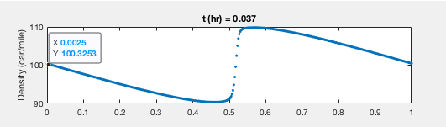

Figure 2: The figure shows the density in traffic flow for the time 0.037 hr and density 100.32 car/mile.

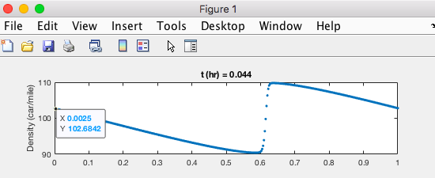

Figure 3: The figure shows the density in traffic flow for the time 0.044 hr and density 102.68 car/mile.

From the figure 2, we can find that t1= 0.037 hr and x1=0.5 mile.

From the figure 3, we can find that t2= 0.044 hr and x2=0.6 mile.

Distance, X=x2-x1=0.6 – 0.5 =0.1 mile

Time, T= t2- t1= (0.044- 0.037) hr= 0.007 hr

Wave speed, C= X/T= 0.1/0.007= 14.2 mile/hr

Using the analytical formula (equation 3):

q_max= 4375 cars/hr

rho_max=250 cars/mile

rho= (100.32+102.68)/2= 101.50 cars/mile

Wave speed, C= 8 $\frac{q_max}{rho_max}\left(\frac{1}{2} - \frac{rho}{rho_max}\right)=8*\frac{4375}{250}\left(\frac{1}{2} - \frac{101.5}{250}\right)=13.16 mile/hour$

*

2.

a) f=0.25, p=0.12, del_t=0.00001 hrs, t_final=0.1hrs



Figure 4: The figure shows the waves in traffic flow. The figure is plotted using tstop=0.1 hr, dt=0.00001 hrs, distance= 1 mile, fraction of maximum density for the initial density = 0.25, and peak=0.12. The sound speeds depend on the density, the waves act like sound waves in a compressible fluid: compression waves steepen, and expansion waves spreads out.

b)

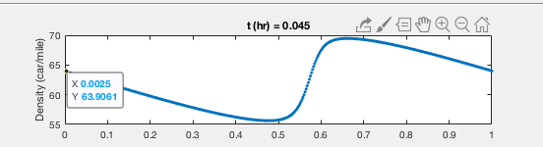

Figure 5: The figure shows the density in traffic flow for the time 0.045 hr and density 63.90 car/mile.

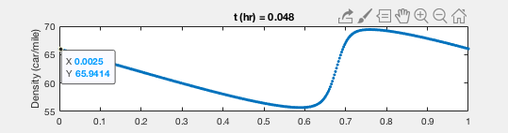

Figure 6: The figure shows the density in traffic flow for the time 0.048 hr and density 65.94 car/mile.

From the figure 5, we can find that t1= 0.045 hr and x1=0.5 mile. From the figure 6, we can find that t2= 0.048 hr and x2=0.6 mile.

Distance, X=x2-x1=0.6-0.5=0.1 mile

Time, T= t2- t1= (0.048- 0.045) hr= 0.003 hr

Wave speed, C= X/T= 0.1/0.003= 33.33 mile/hr

Using the analytical formula (see CP# 11 equation 3):

q_max= 4375 cars/hr

rho_max=250 cars/mile

rho= (63.90+65.94)/2= 64.92 cars/mile

Wave speed, C= 8 $\frac{q_max}{rho_max}\left(\frac{1}{2} - \frac{rho}{rho_max}\right)=8*\frac{4375}{250}\left(\frac{1}{2} - \frac{64.92}{250}\right)=33.64 mile/hour$

*

c)

The change of the fraction and peak values affects the density function as well as the wave speed. For the sample case, the density, flow, and velocity have higher values than the case 2 b. Those values affect the wave speed. The density is higher in sample case, so it gives the wave speed almost 14 mile/hr. But the wave speed has increased for case 2 b with small f & p. Also, with small f & p values, the compression waves shows less steepen than sample case.